Gräbner et al. (2021): “Understanding economic openness: a review of existing

measures”, Review of World Economics, vol. 157, pp. 87-120

1. Introduction

International economics = study of economic openness and its impact on domestic and foreign economies
→
- Many dimensions
- Many measures
→
- Which measures are available?
- Are the measures correlated?
- Are they related to economic growth?

Purpose of paper (p. 88)
- Listing of different openness indicators
- Implications / understanding of different indicators
- Dataset of openness indicators

2. Measures of economic openness

International economics → international economic openness → what is national and what is international? [political dimension]
- (Bavaria – Hessen) vs. (Estonia – Latvia)
- Estonia vs. EU

International openness
- Real = trade in goods and services ← only covered briefly here!
- Financial, incl. cross-border ownership
- International labour mobility & migration ← not covered here!
- “Ideas” ← not covered here!

Trade and finance tied together → balance of payments [more later]

How measure?
- De jure (legal, rules)
- De facto (the size or extent of international economic variables)
- The effect on national economic variables affected by openness

Gärbner et al. (2021) → focus on a) and b)

NB1: Conclusions from de jure and de facto measures can be very different
- E.g.: USA had (sic!) few trade restrictions, but never traded relatively little

NB2: The effect cf. c) may be very important [more later in course!]
- E.g.: Electricity prices in EE, stock market prices

NB3: “Hybrid” measures → combining various measures (e.g. real and financial measures, de jure and de facto measures)

3. Descriptive statistics for openness indicators (p. 97)

Economic complexity (Hidalgo & Hausmann 2009) ≈ economic development level
- High, medium, low

NB: Trade is gross measure, but GDP is a net measure (sum of value added)
→
If country imports car, paints new stripes on side of car, exports the car with stripes
- Trade large
- Value-added small
→
Now also measures that considers only value-added in trade (e.g. value of stripes on side of car)

Trade: Figure 1 
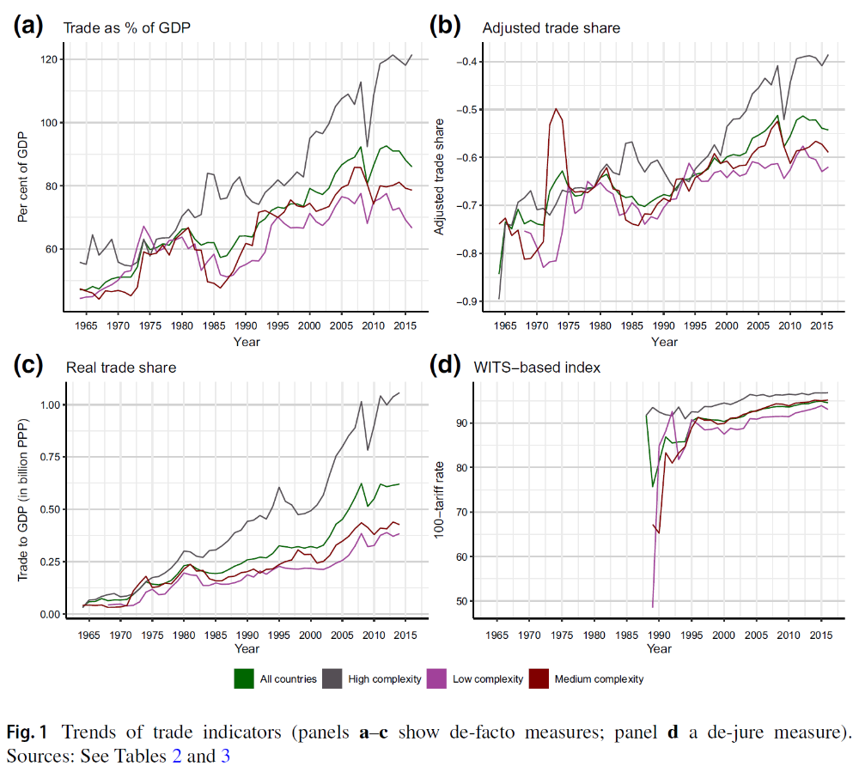
Imports divided by GDP, adjusted for the nation’s share in world production (addresses the “size bias” ← large countries with large GDP trade little in % of GDP)
100 – mean of effectively applied (AHS) and most-favored nation (MFN) weighted average tariff rates

NB: WITS = World Integrated Trade Solution databank of the World Bank
Trade = X (exports) + M (imports)
Trade Volume (X + M) in % of GDP at PPP

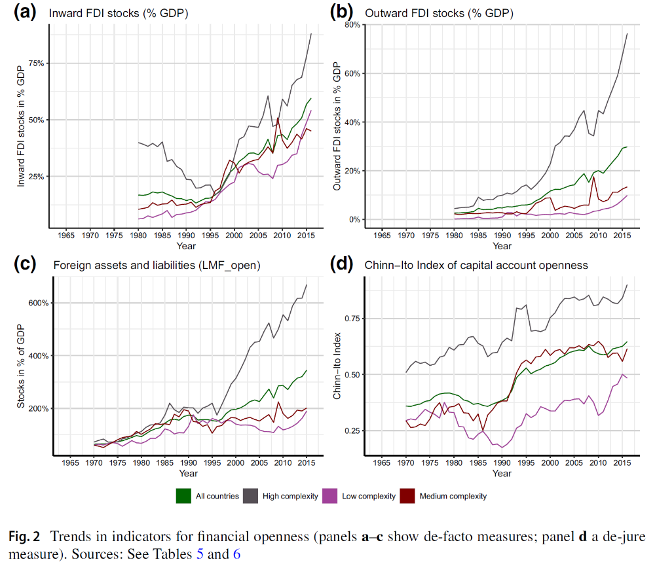
Presence of multiple exchange rates
Restrictions on current account transactions
Restrictions on capital financial account transactions
Requirement of the surrender of export proceeds

4. Do different measures of openness agree? A correlation analysis

NB1: More measures than those shown above
- … including hybrid / composite indices (here: KOF)

NB2: Trend and/or unit roots in many of the measures
⇒
Consider both:
- Measures in levels
- Measures in first differences

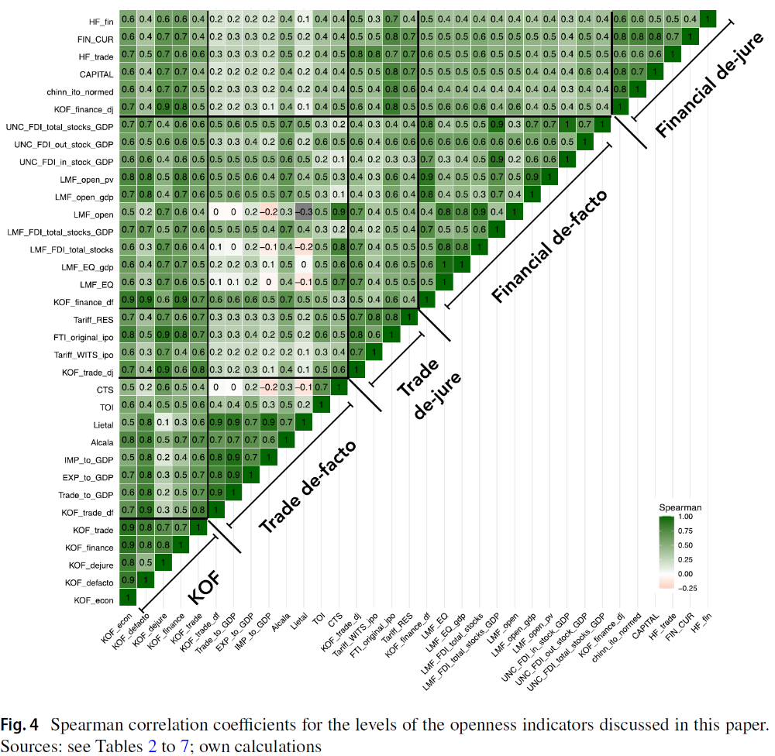
KOF → hybrid / composite indices
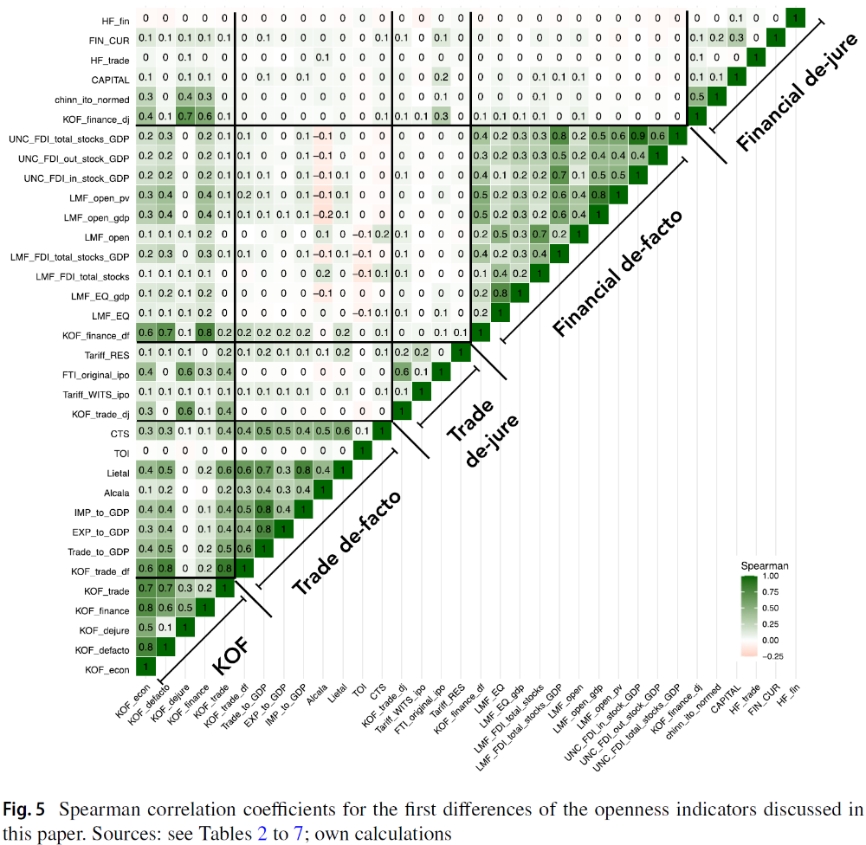
Conclusion
- Some correlation between levels of measures
- … though measures of trade openness and financial openness not much correlated
- Some correlation between levels of KOF hybrid measures and individual measures ← self-evident!
- Very little correlation between changes / dynamics of measures
Application: the choice of economic openness measures makes a difference in growth regressions

Questions
- Which openness measures are related to economic growth?
- What is the sign and size of possible relationships?

Econometric model in levels (5-year averages)

i = country index
t = time index (year, 5 years)
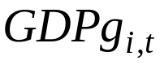 = economic growth
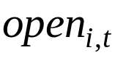 = openness indicator (α = coefficient to be estimated) ← NB: only one openness indicator included at a time
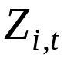 = vector of control variables
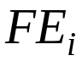 = Country Fixed Effect

Estimate model with annual changes in openness variables and control variables (and no Fixed Effects)
→
FD = FD yearly = First Difference of annual values

Why? Is it OK? [Perhaps address I(1)]

Results
- Main results when in 5-year levels → results differ a lot depending on specific indicator used ☹ & many “unreasonable” signs ☹ & few statistically significant results ☹
- Main results when Δ → results differ a lot depending on specific indicator used ☹ & many “unreasonable” signs ☹ & few statistically significant results ☹

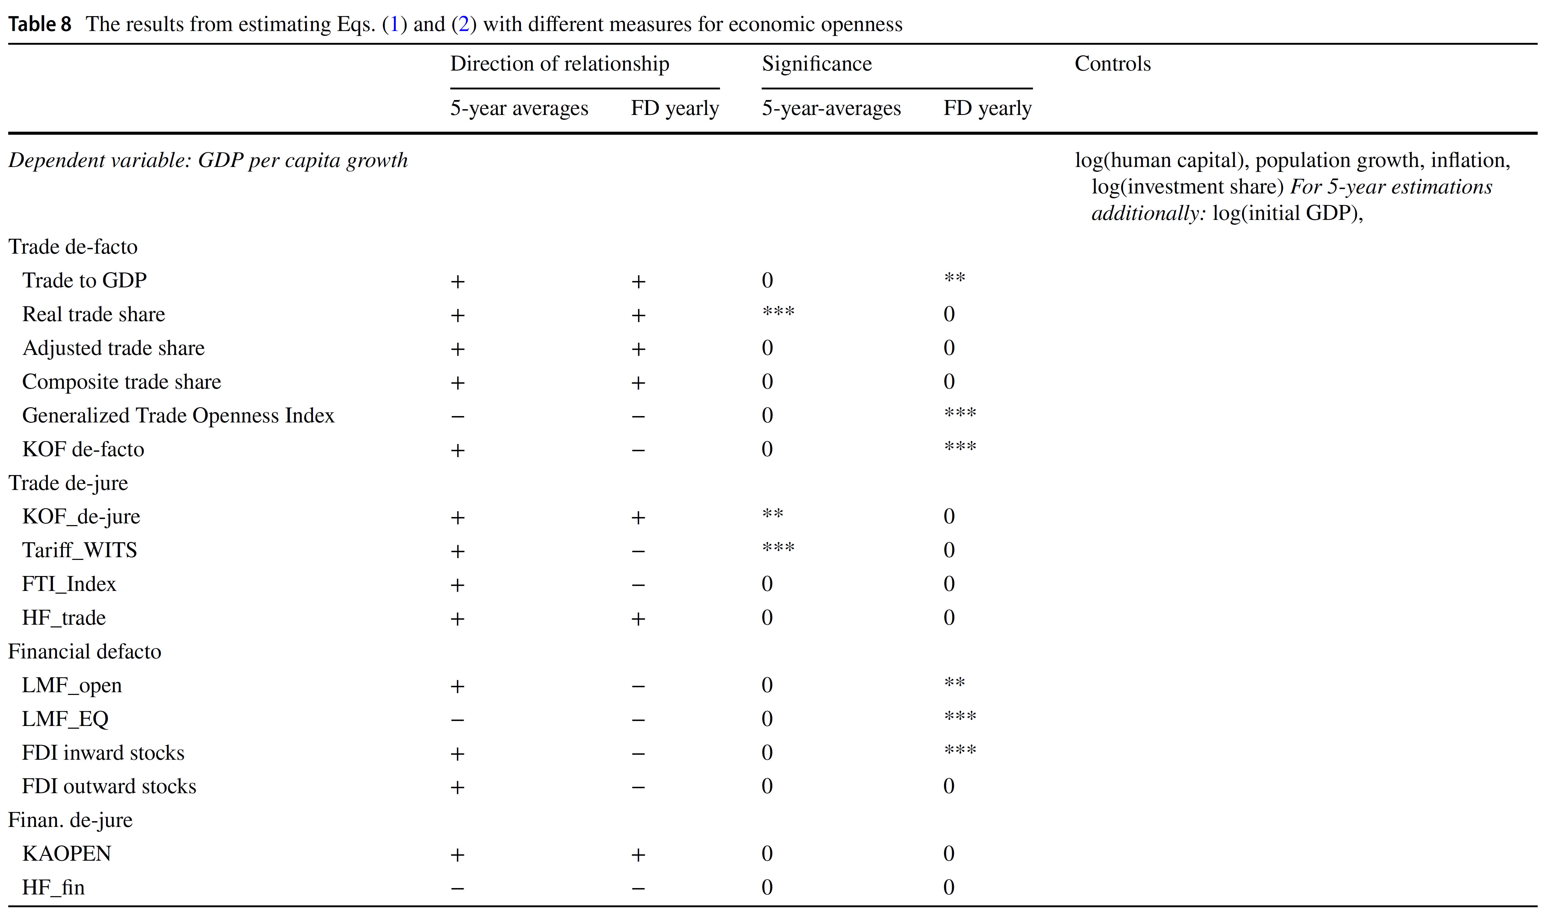

Econometric analysis
- Main results ☹
- Very sensitive results
  - Positive spin → important to consider carefully which indicator to use! Hmmm! 😐

Multitude of econometric problems!
- Lag structure
- Reverse causality
- Omitted variables bias (including no lagged dependent variable)

6. Conclusions

Findings
- Overall greater international economic openness (at least until publication in 2017)
- Variation across various groups of countries
- Variation across various real and financial indicators
- Difficult / impossible to link indicators to economic growth

